**Manual Testing**

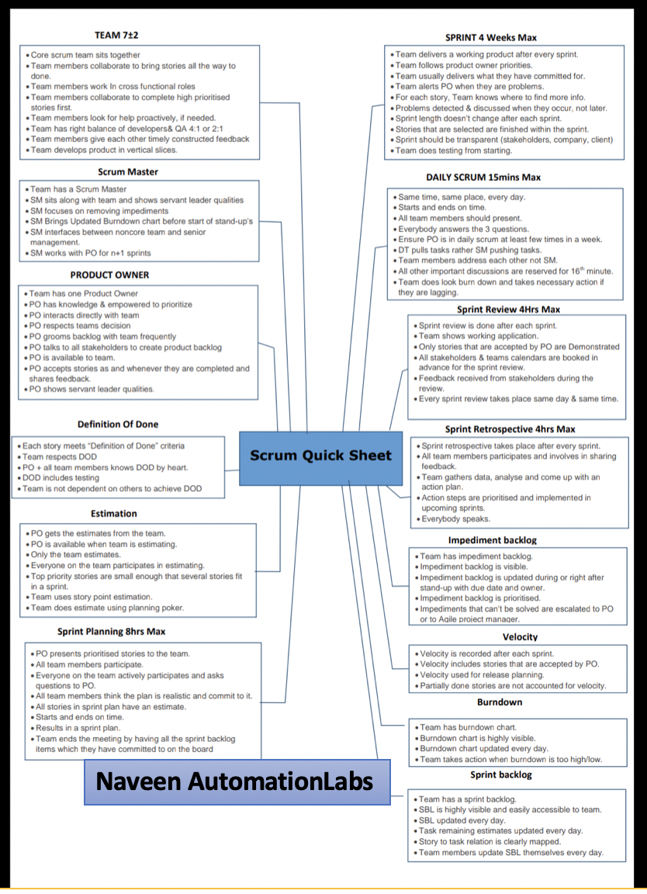

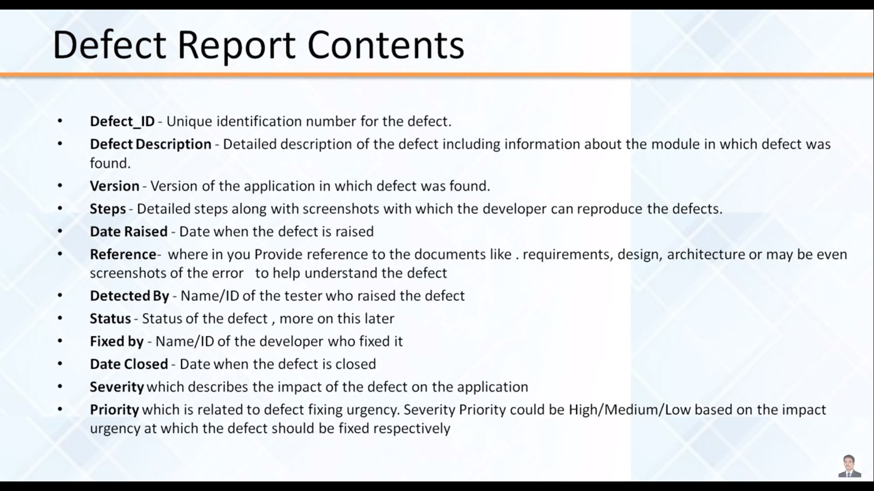

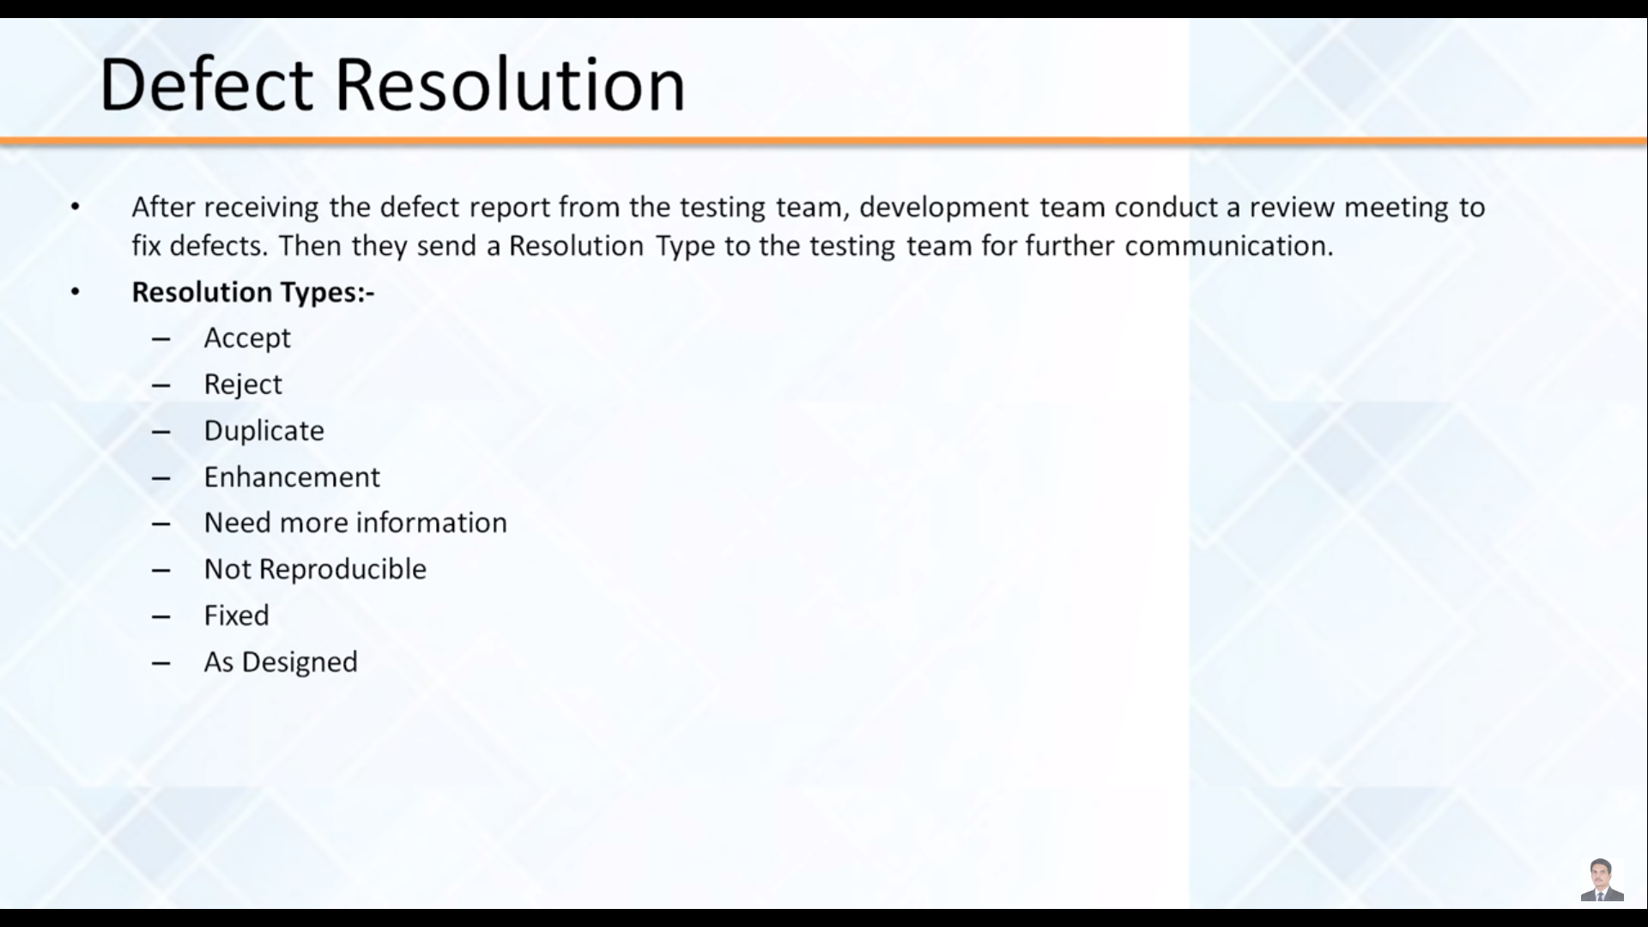

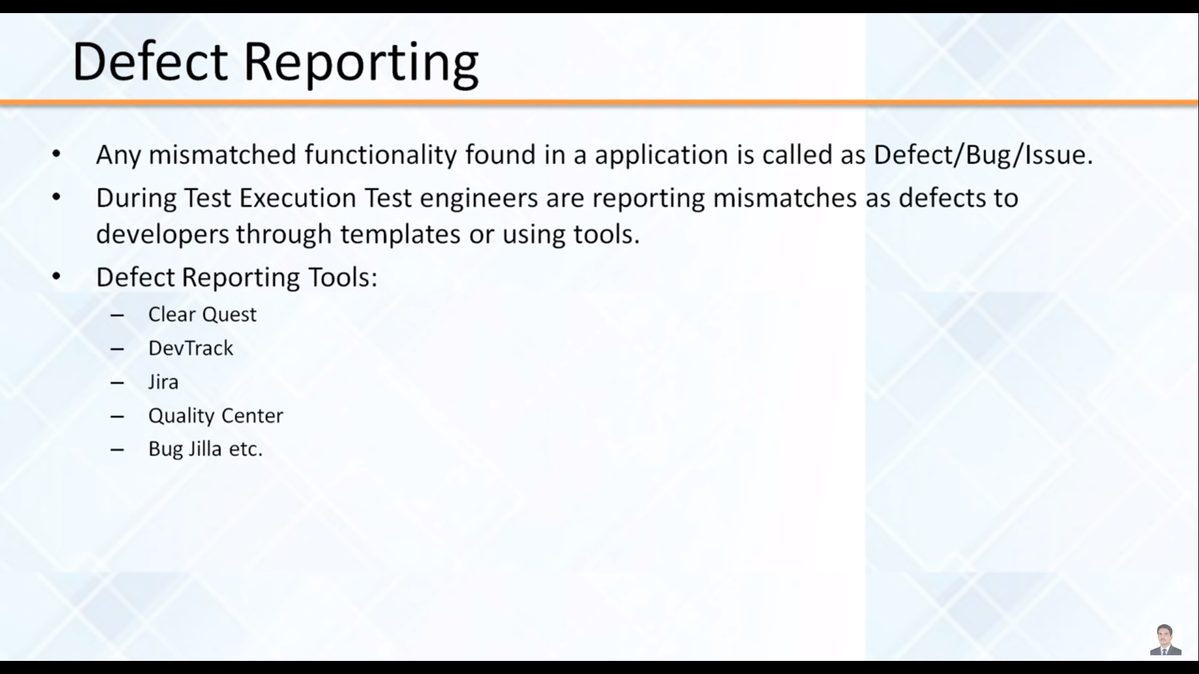

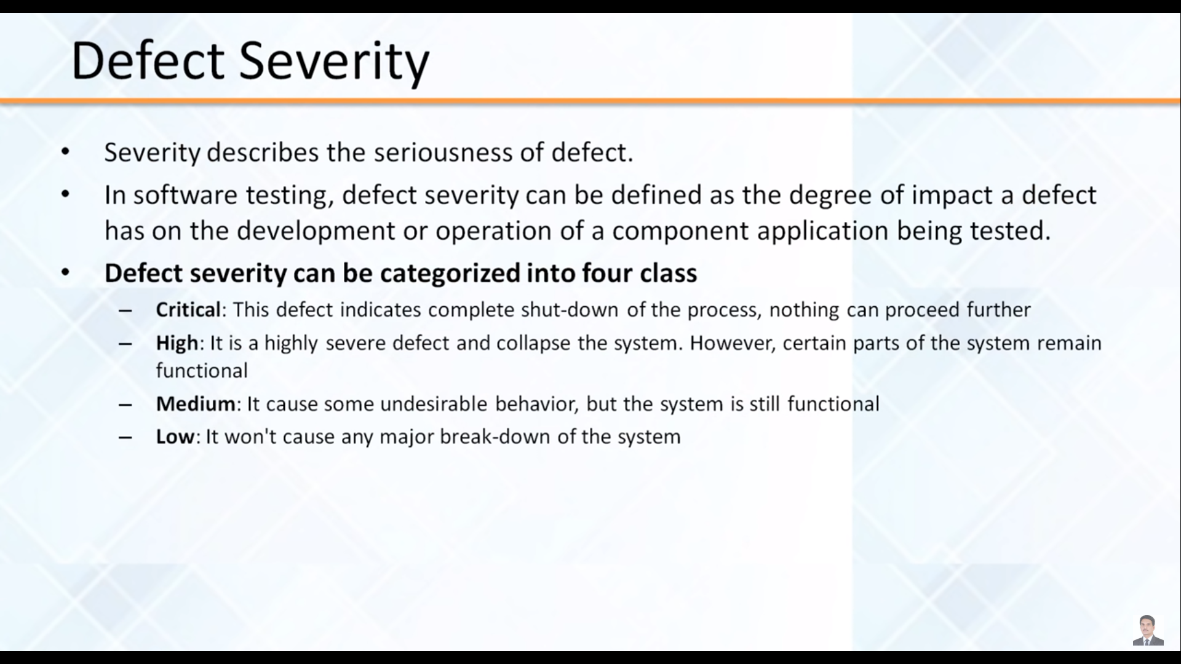

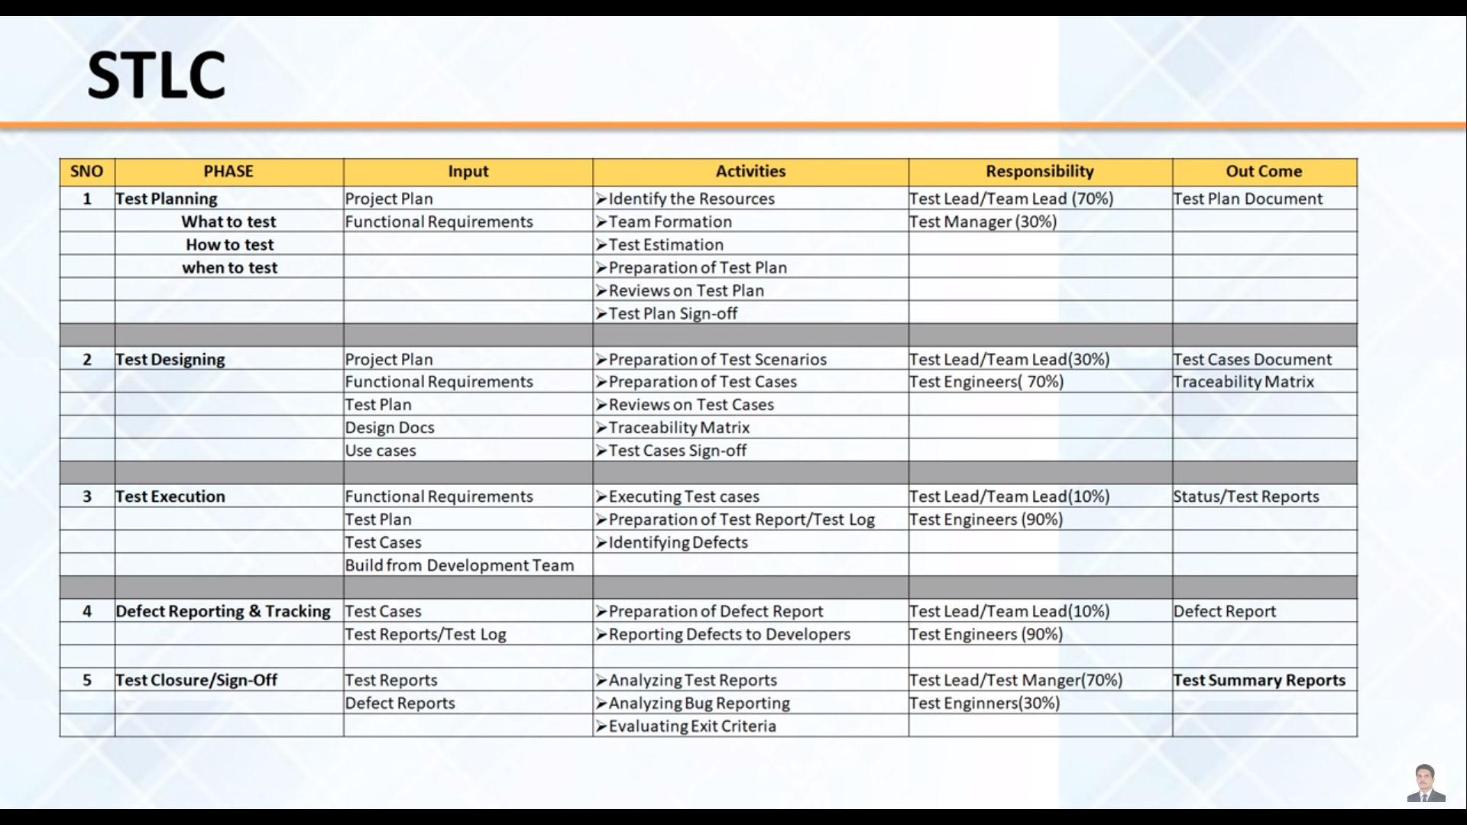

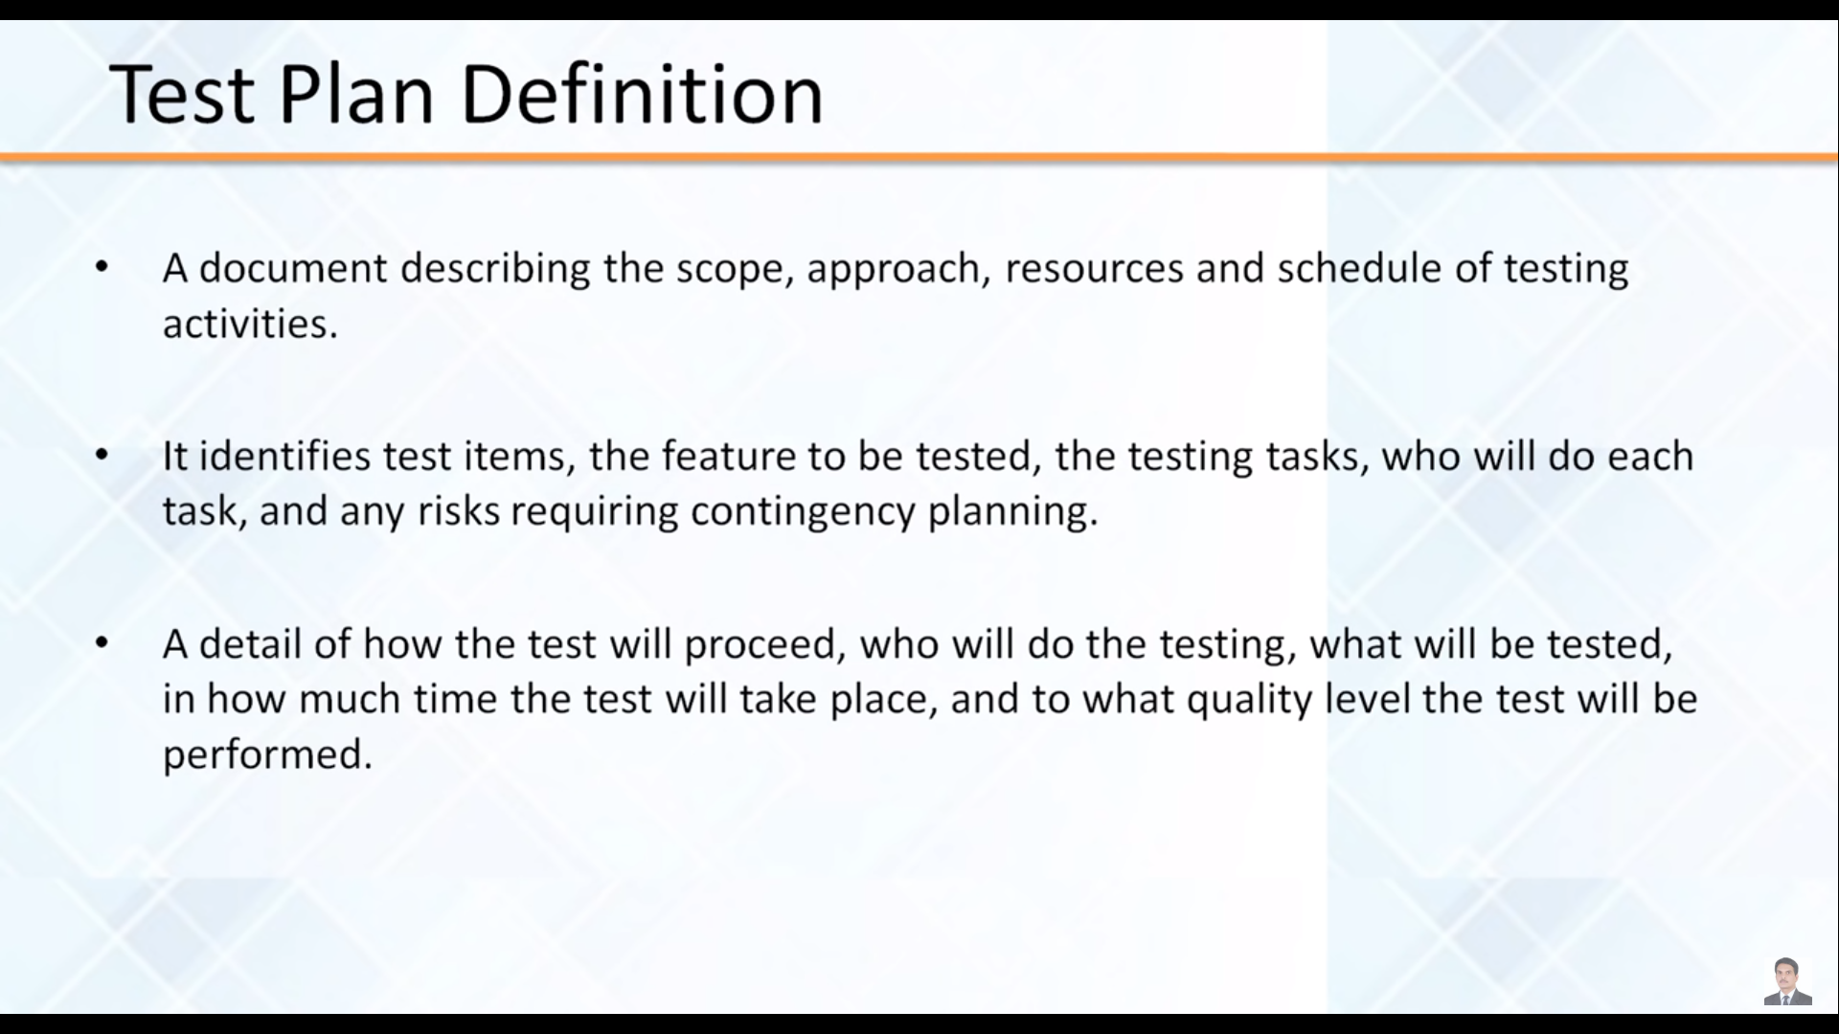 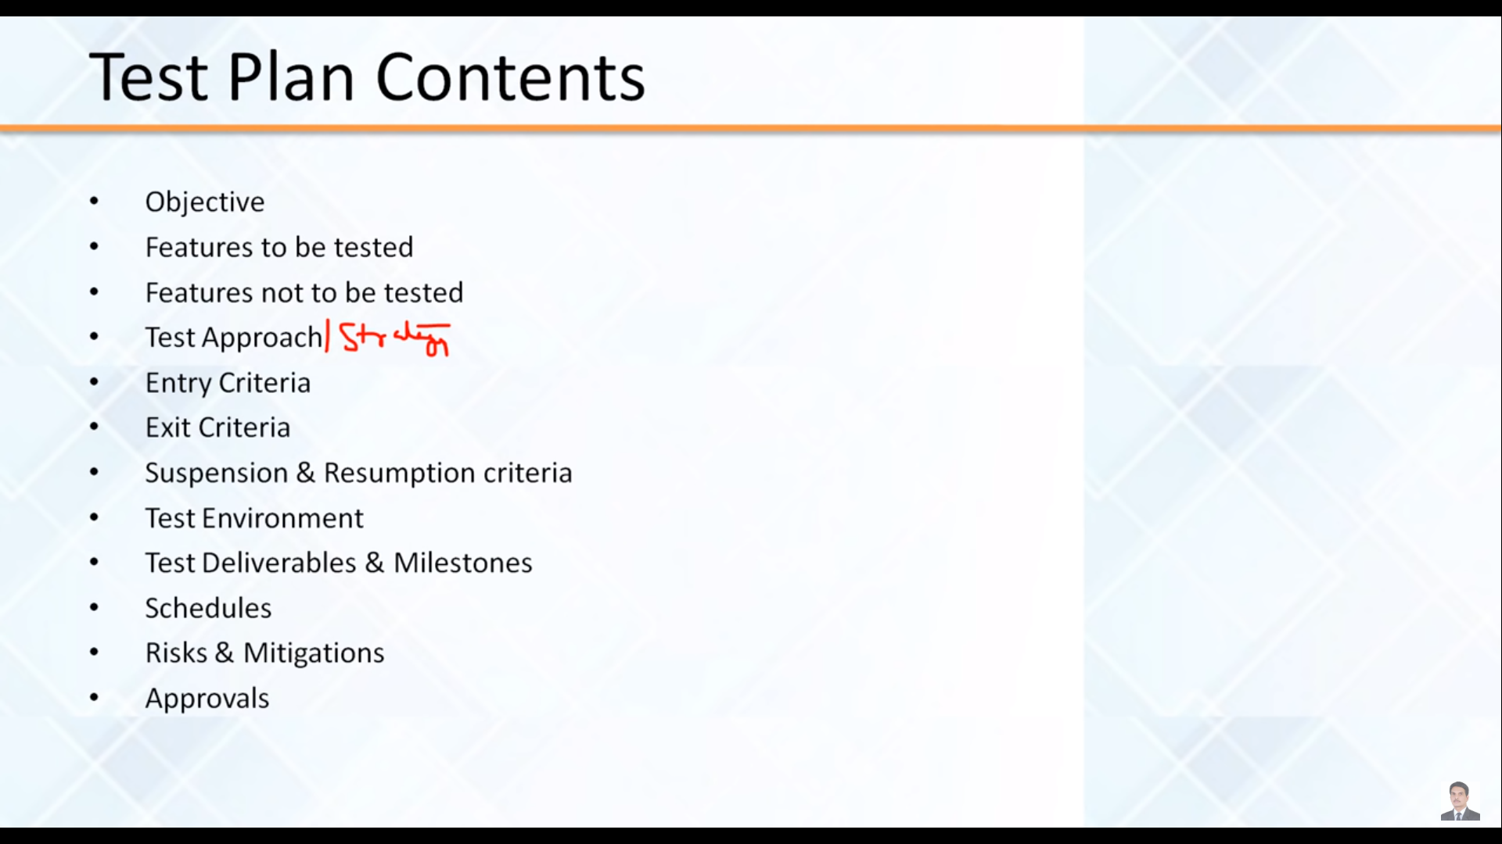 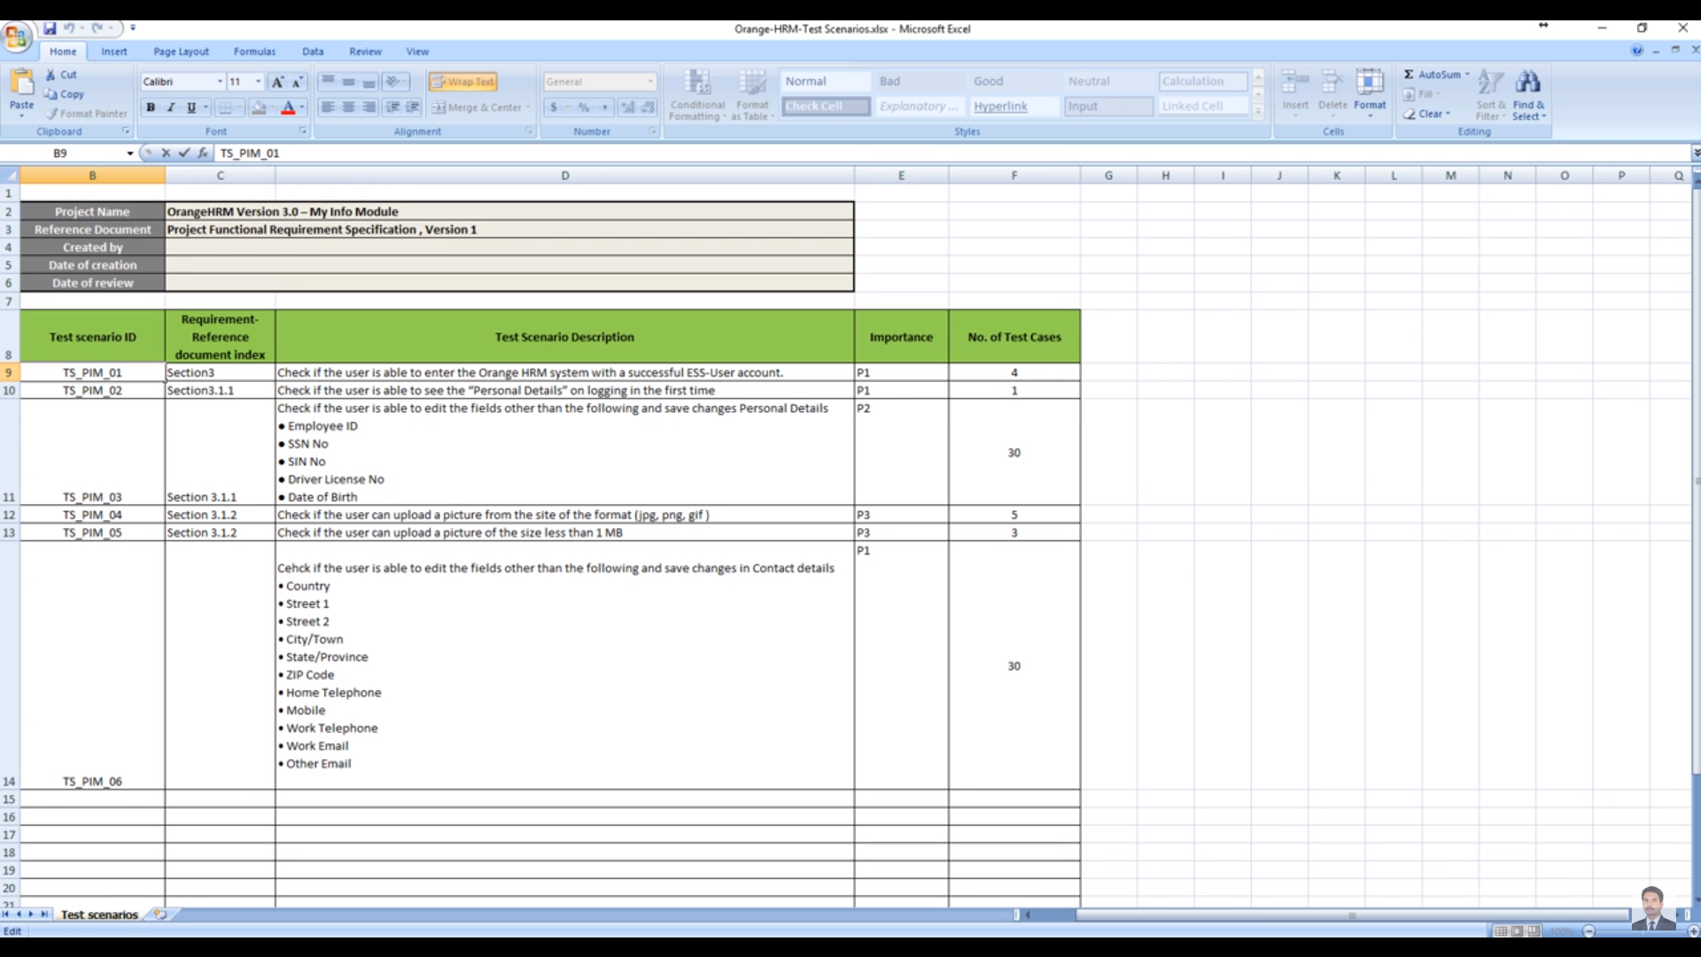 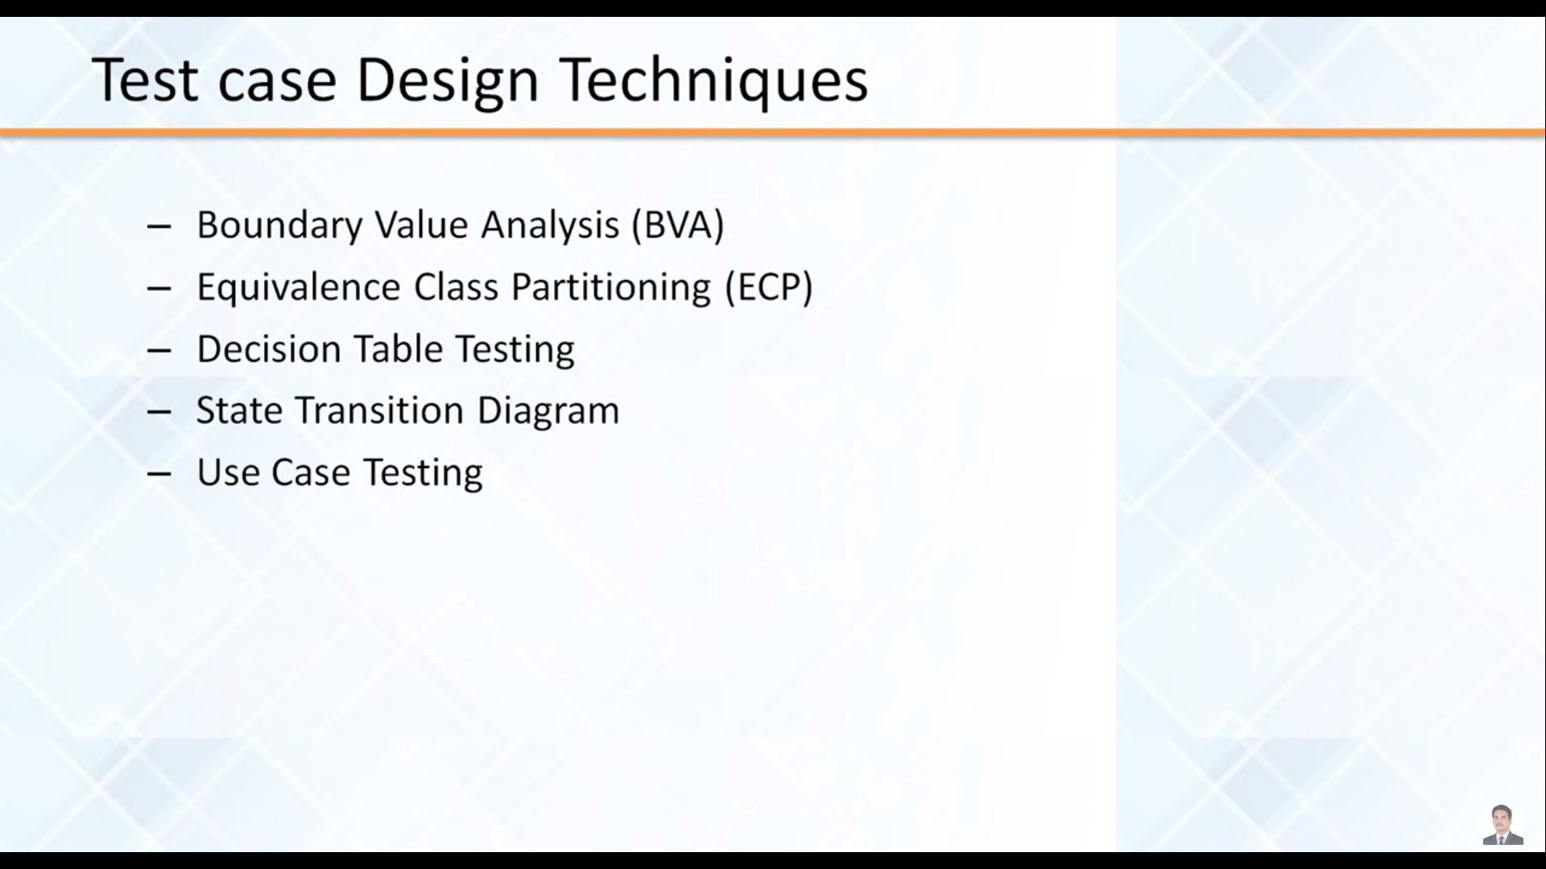 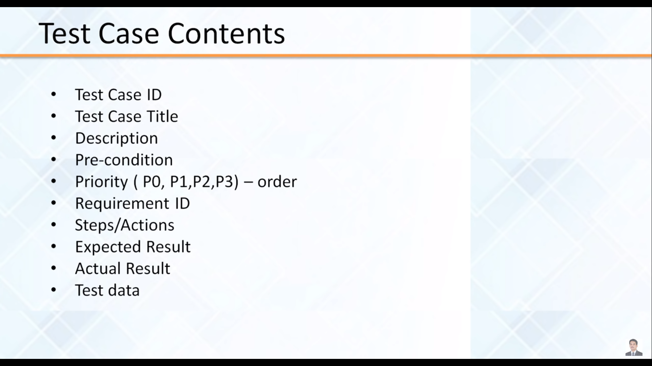

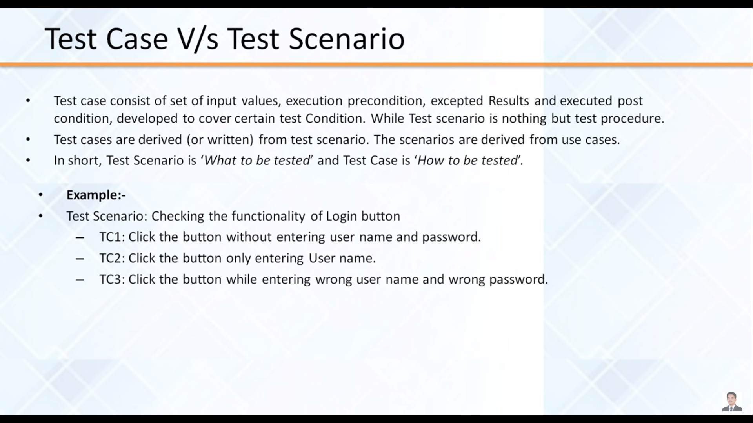 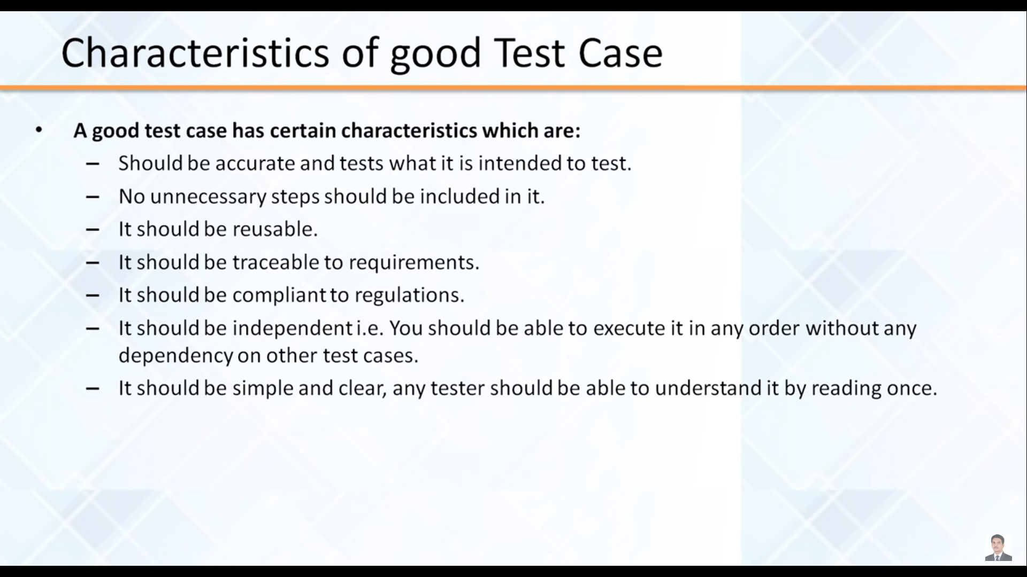

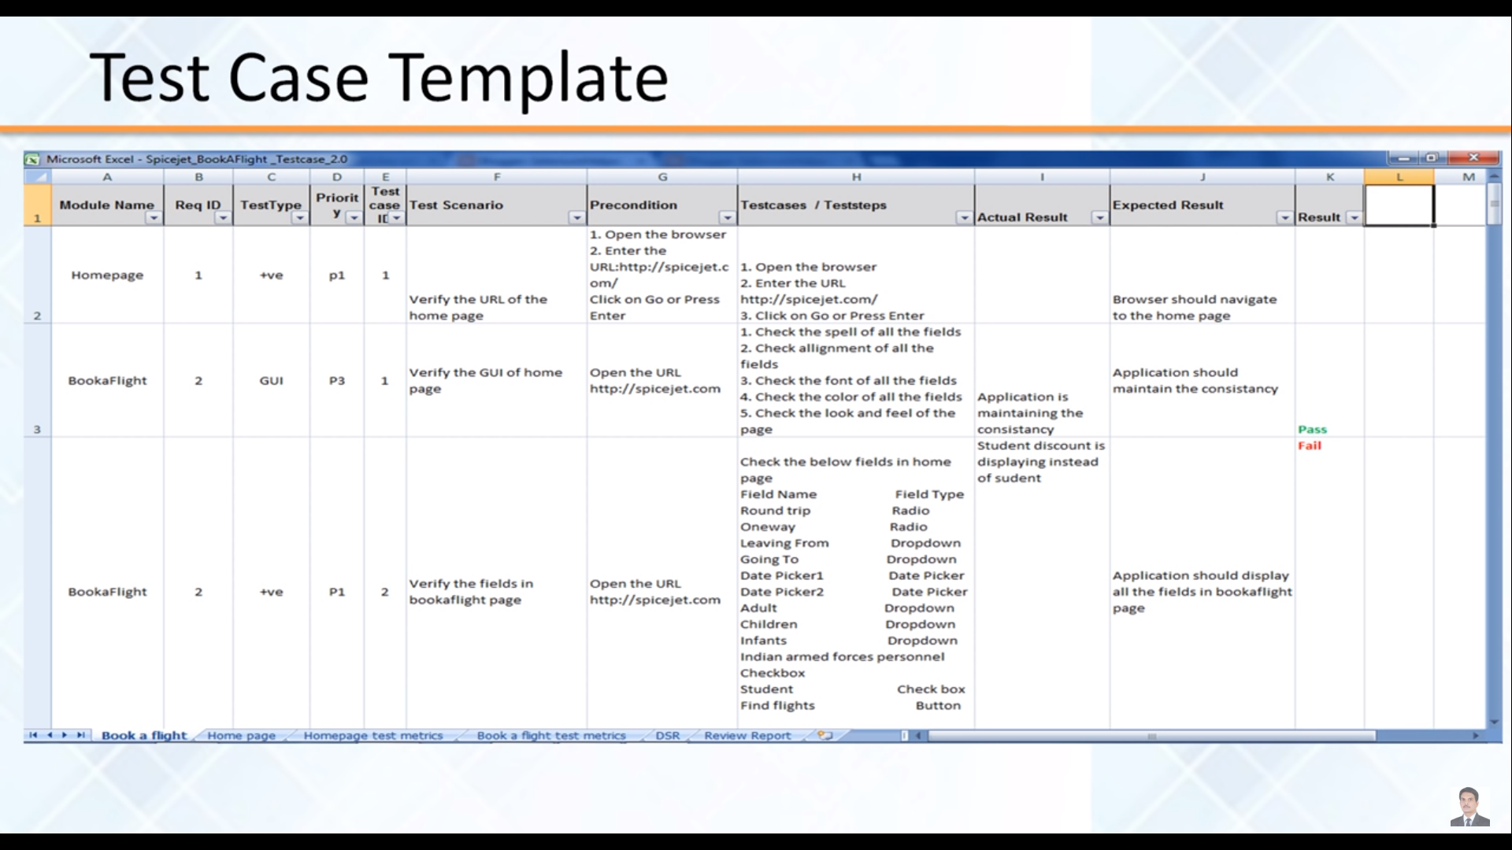

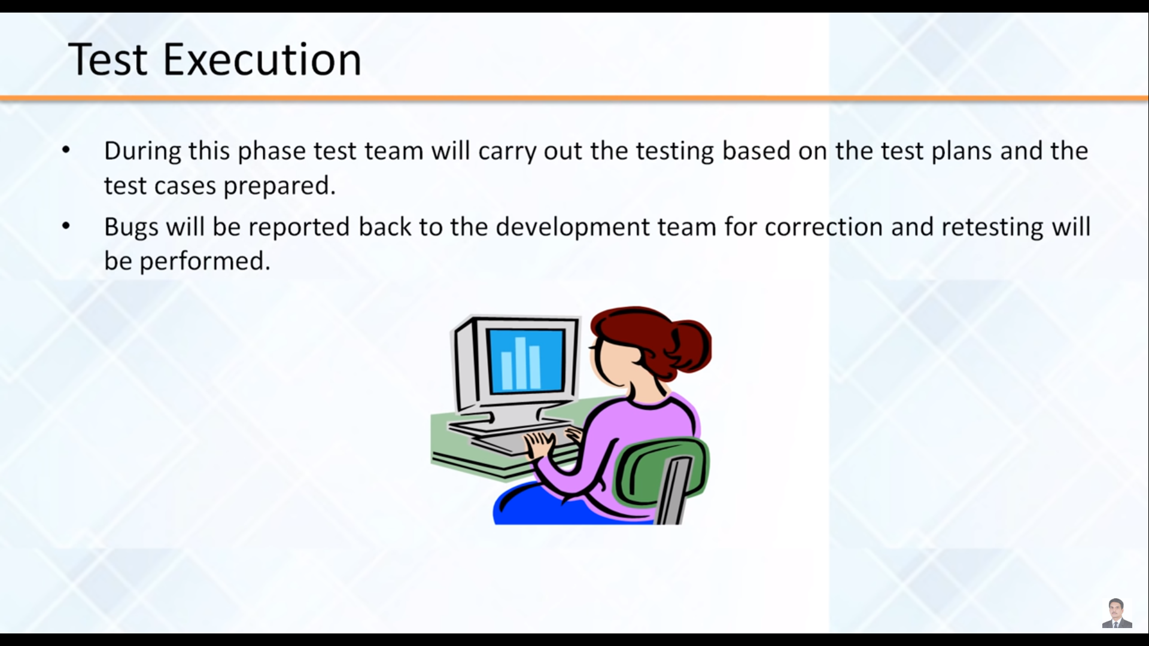 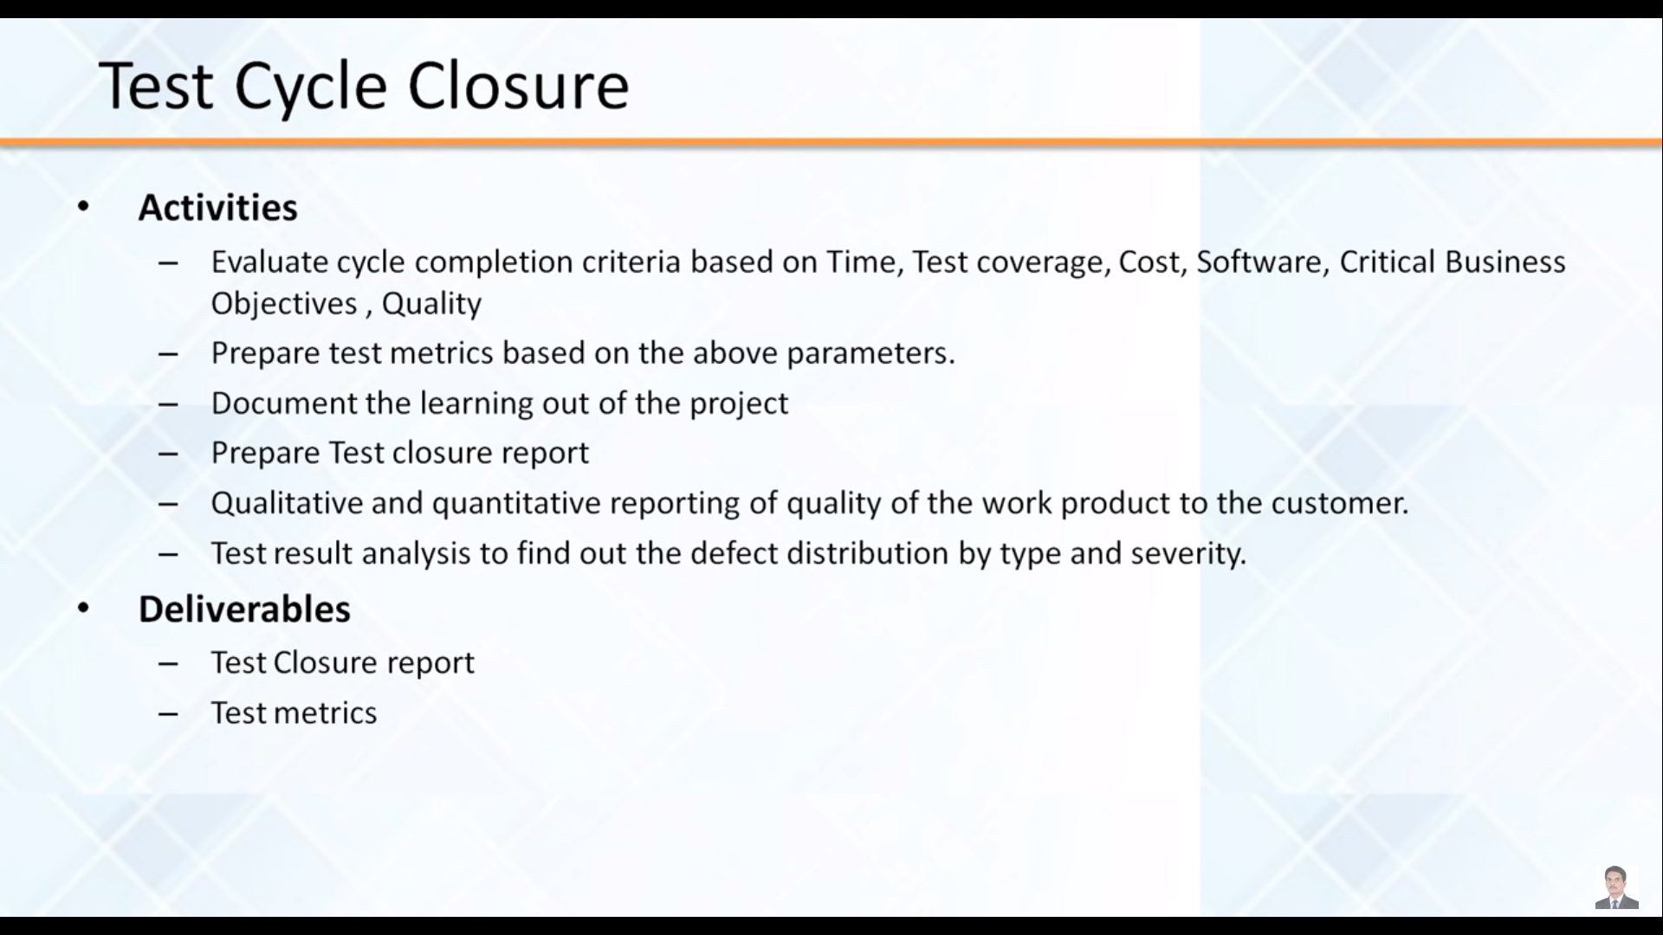 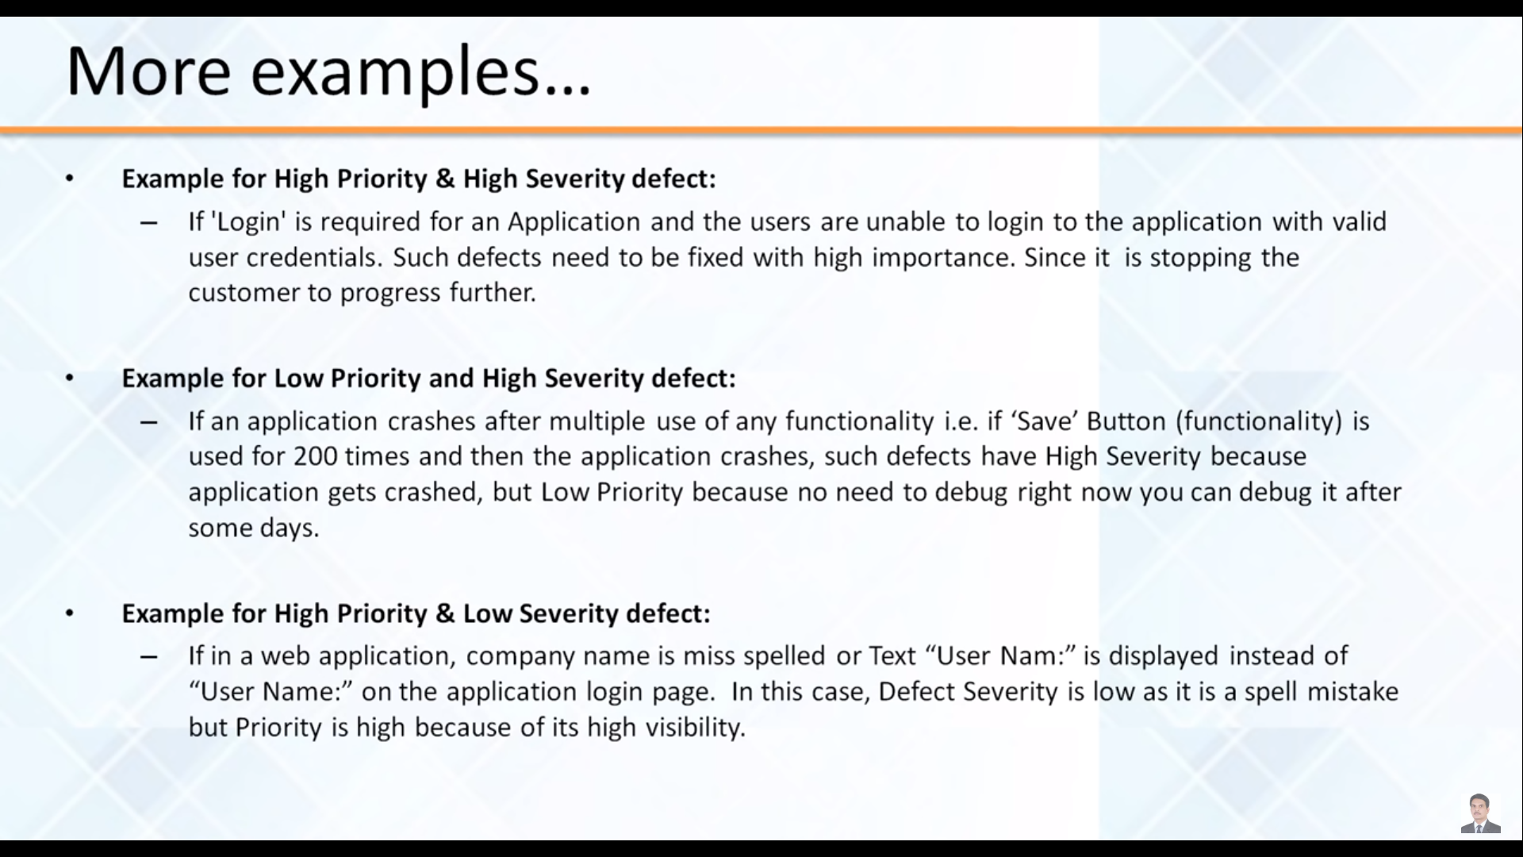 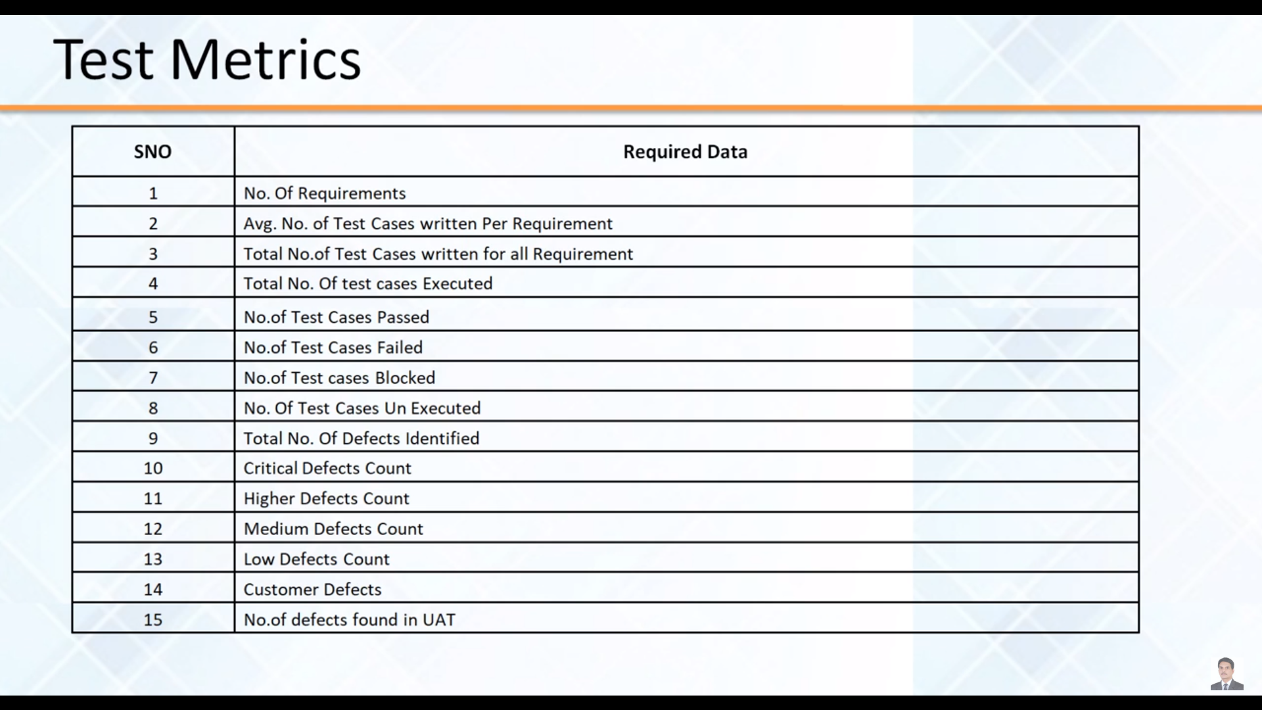 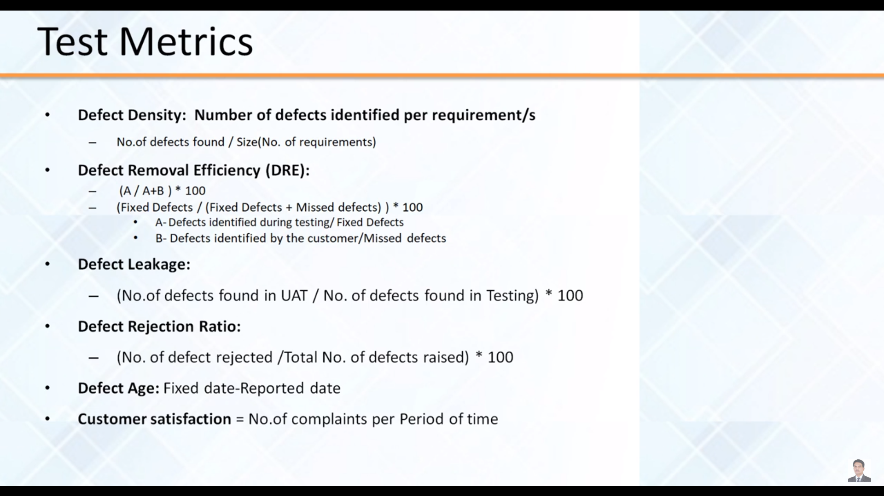 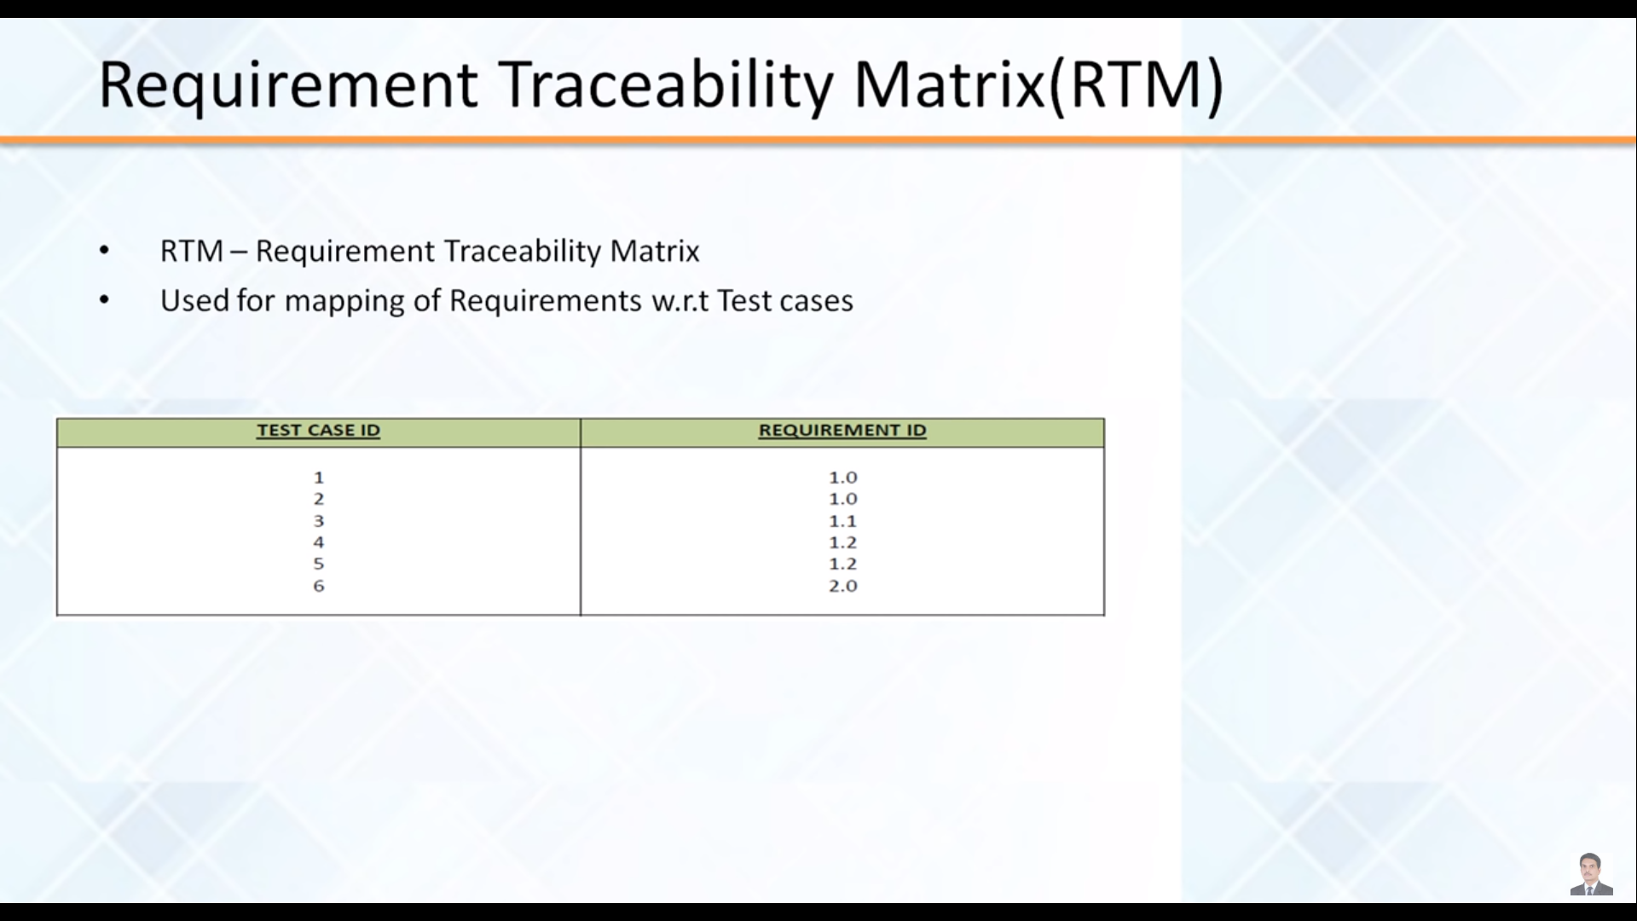 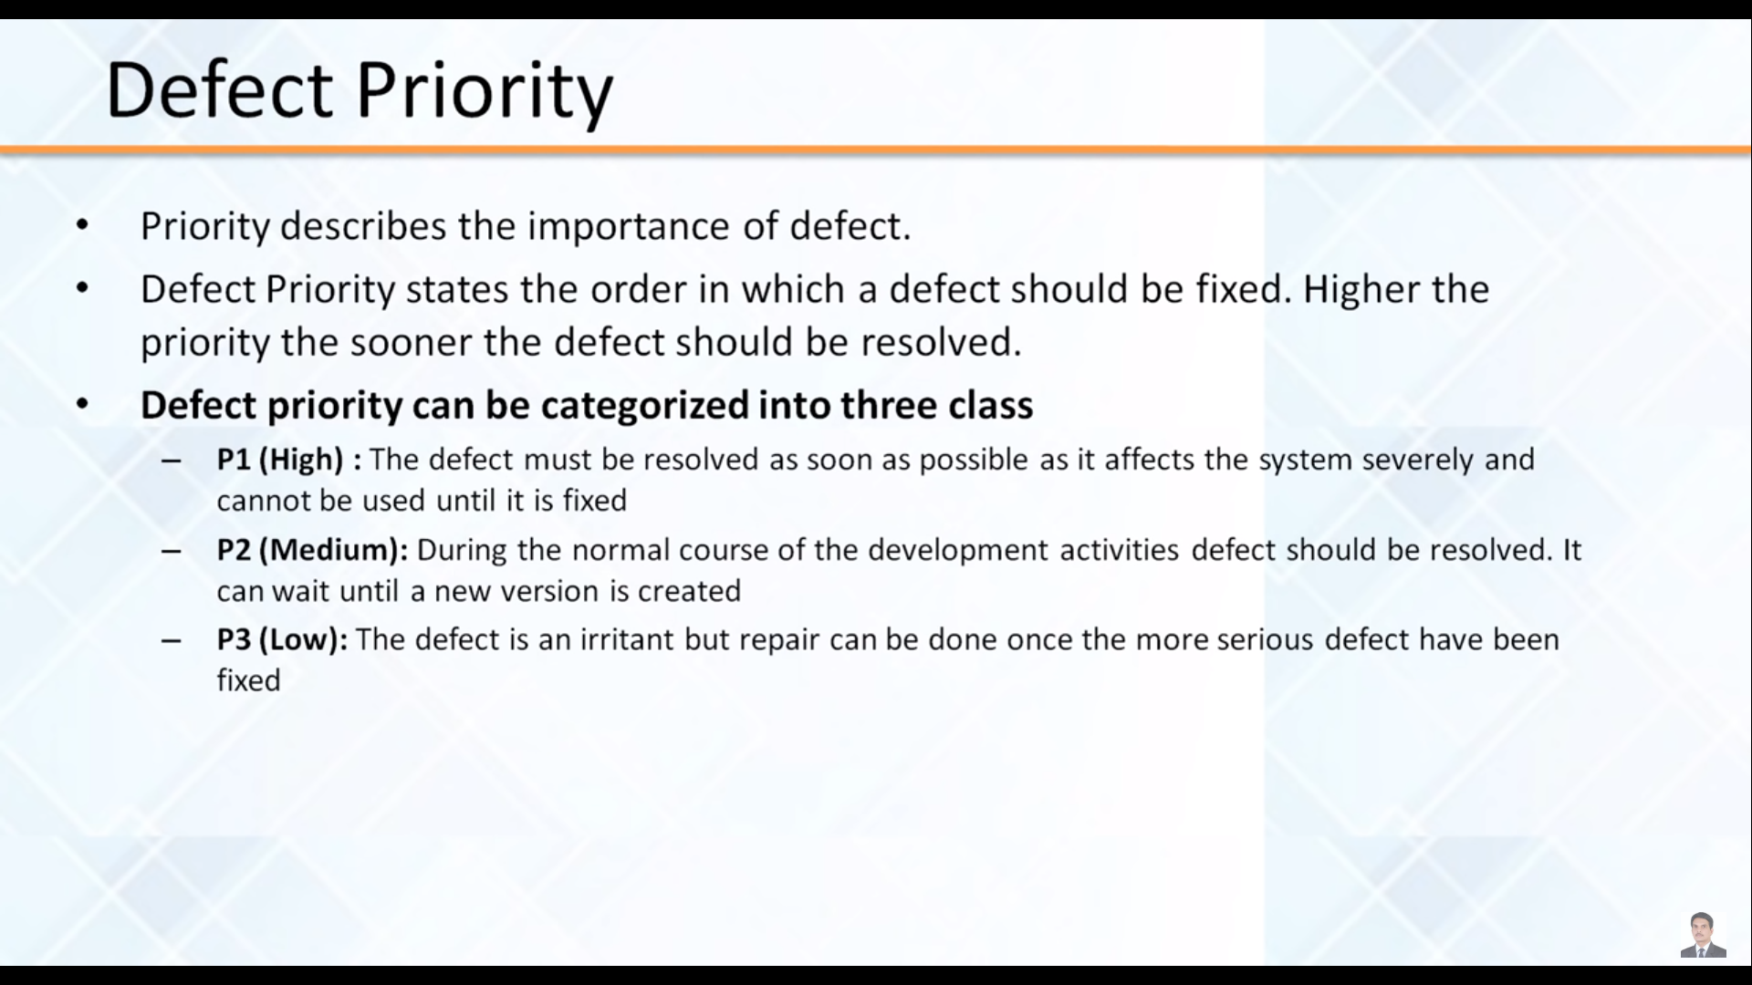

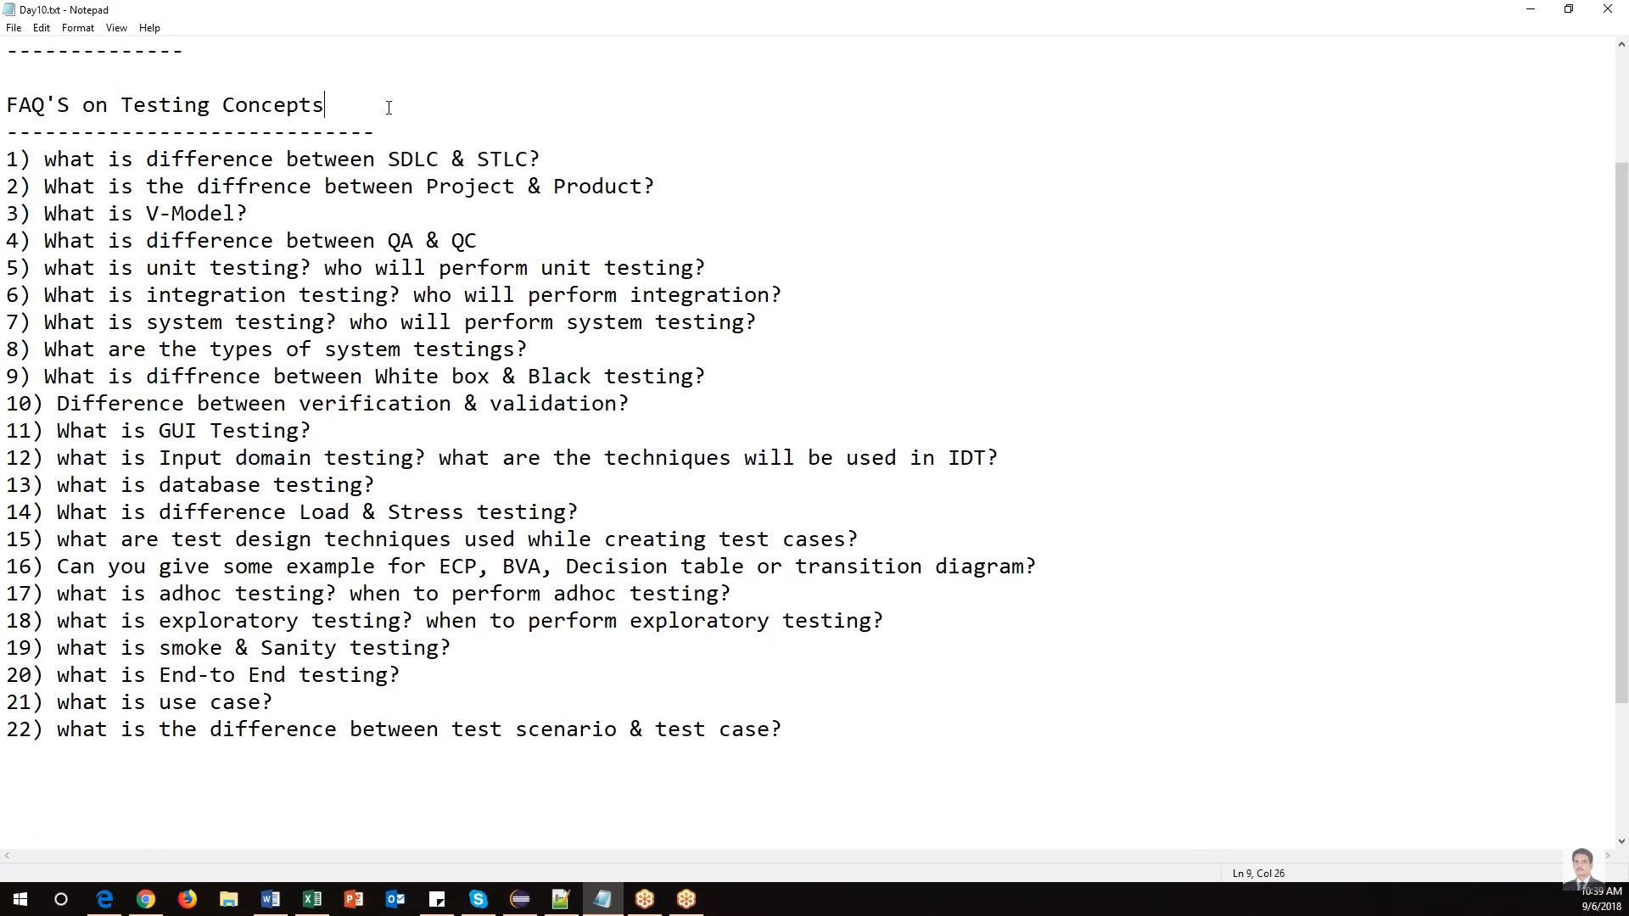

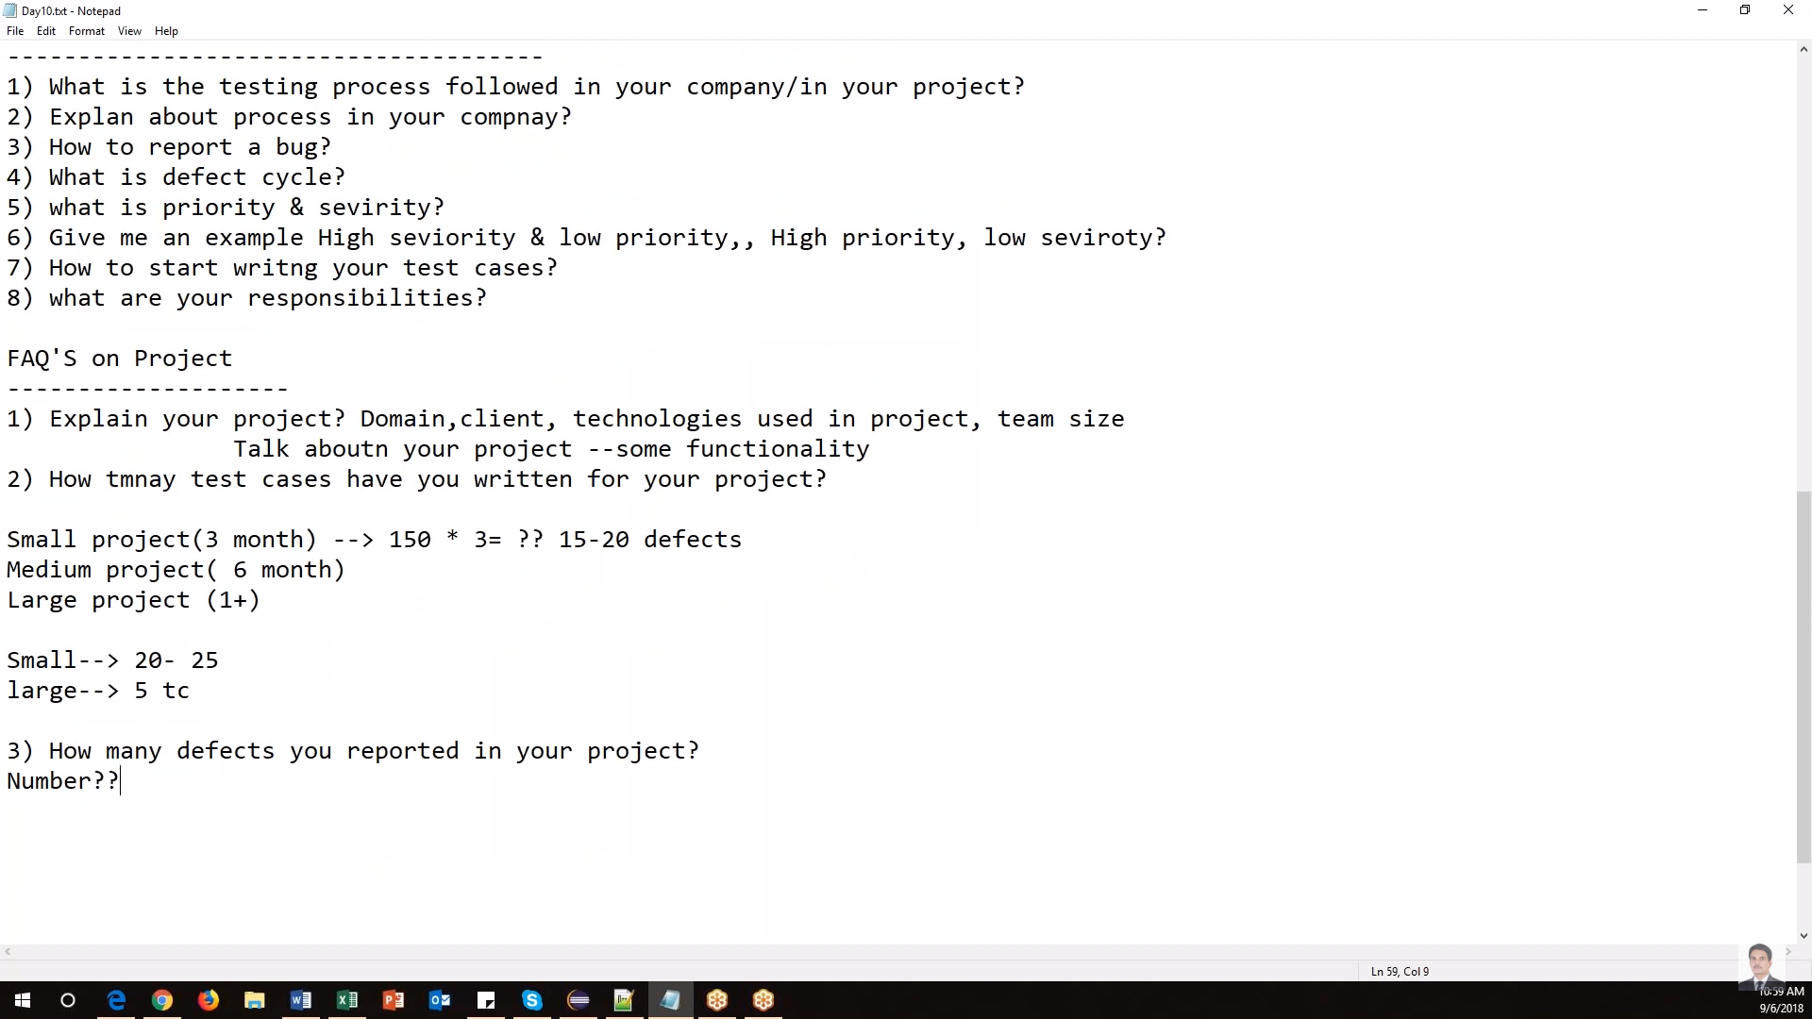

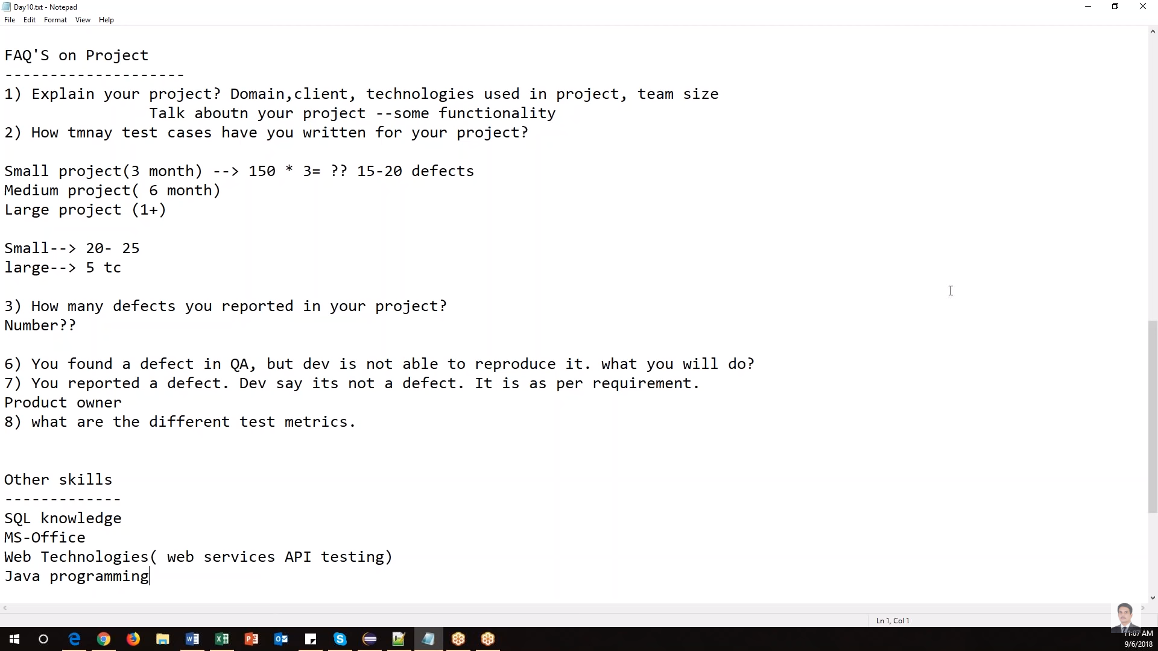

**Ques - What is STLC, SDLC, ATLC and explain?**

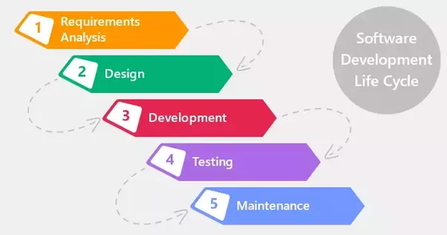

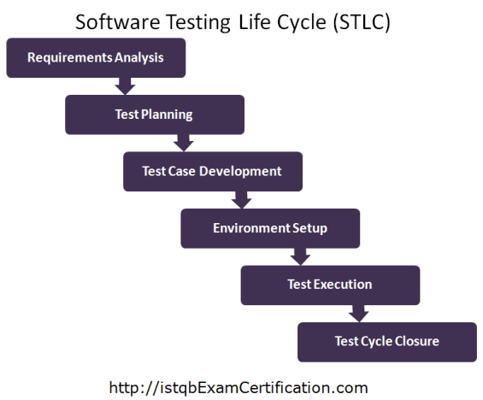

**V-Model**

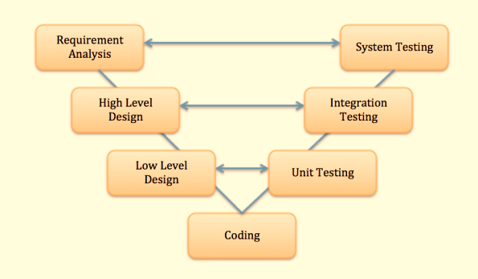

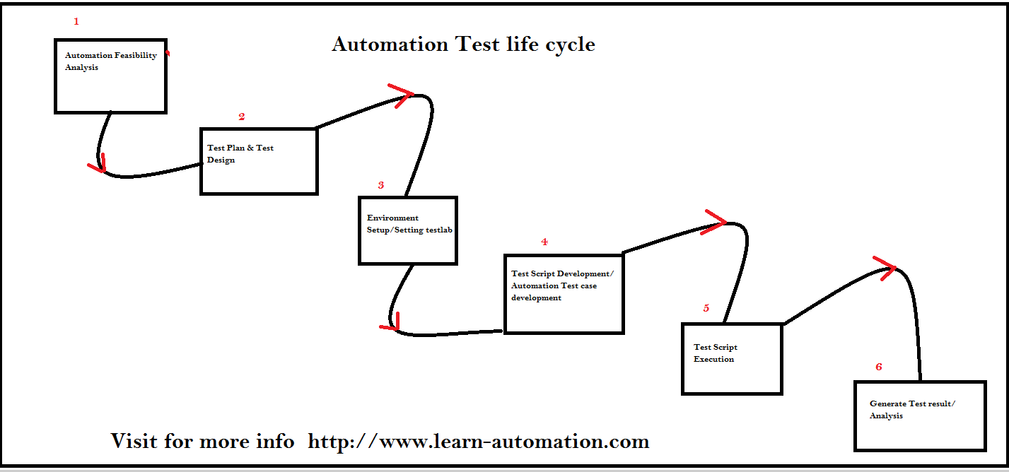

**Ques - Defect/Bug life cycle?**

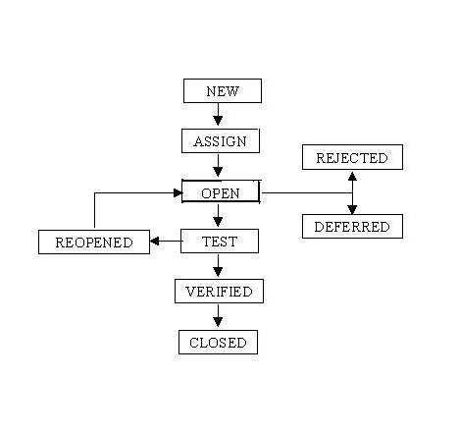

**Ques - Defect management tool – ALM/QC explain their components?**

HP ALM (Application Life Cycle Management) is a web based tool that helps organizations to manage the application lifecycle right from project planning, requirements gathering, until Testing & deployment, which otherwise is a time-consuming task. supports various phases of the software development life cycle.

**Ques - What type of testing you performed in your project?**

I performed System testing, functional testing, regression testing, smoke, sanity and UAT testing of different different products on different different channels on different different environments.

I tested commercial insurance products and for that one we performed Pricing testing, UW rule testing and Documents testing.

Commercial Insurance includes cover for almost all entities which are not categorized under Personal Insurance like Life Insurance, Health Insurance among others. Products are like

* Minifleet
* Property Owners
* Shops
* Hotel and Guest House
* Pub and Restaurant

Insurance covers are provided by the many Brands which it owns and also by partner banks few of which are mentioned in this document.

**National Insurance Group (NIG)**

**Direct Line For Business (DL4B)**

**Churchill for Business (C4B)**

**NatWest**

Each of the Brands has different Channels through which the various insurance products can be accessed directly by customers or by brokers for obtaining a cover.

**Stages of an Insurance policy –**

**Request for Quote –Quote –New Business (NB)/Policy –Mid Term Adjustment (MTA) –Cancellation –Renewals** .

**Product Testing –**

Product Testing extensively includes –

* Web UI Testing
* Underwriter Rules Testing
* Documentation Testing
* Pricing

**Web User Interface Testing –** UI Testing involves testing of the application’s build for each product in every channel. We test whether the risk questionnaire for a product, appearing on the application screens is as per the respective **‘Web Specification’** document provided by the business team. Whether all the static and dynamic questions appear correctly, headings and certain messages and wordings are as per the spec. Also, we can test the look and feel of the application.

**Underwriter (UW) Rules Testing –** Underwriting is a term used in Insurance to describe the process of assessing and evaluating the risk to decide how much coverage a client should receive, amount to be paid by the client for the cover he/she seeks and also decide whether to even accept the risk requested by a client.

For this assessment, Insurance Underwriter sets down rules and testing team tests if a product complies with the rules listed for it. Testing team uses the **UW Test Pack (TP)** prepared by the Insurance Underwriter for each product and shared to the team.

In Underwriter Rules Testing there is –

**Testing of Referral Rules –**

**Testing of Declines –**

**Testing of Endorsements –**

**Risk Update-**

**Documentation Testing -**

**Pricing Testing –**

Pricing is a test of premium amounts calculated and generated for an insurance cover.

The Pricing team and the Insurance Underwriter discuss and decide upon the rates and other necessary criteria for calculating the premium amounts for a cover requested by a customer.

Only in the quote obtained stage, when the premium matches, we can perform any overrides mentioned in the TP. Override is a certain percentage/amount of **Discount** or **Load** provided by the Insurer.

**Ques - What is testing and explain their types?**

**Ques - Black box vs white box testing?**

Black box testing is a software testing techniques in which functionality of the software under test (SUT) is tested without looking at the internal code structure, implementation details and knowledge of internal paths of the software. 7This type of testing is based entirely on the software requirements and specifications.

In BlackBox Testing we just focus on inputs and output of the software system without bothering about internal knowledge of the software program.

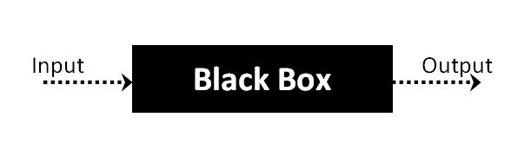

The above Black-Box can be any software system you want to test. For example: an operating system like Windows, a website like Google, a database like Oracle or even your own custom application. Under Black Box Testing, you can test these applications by just focusing on the inputs and outputs without knowing their internal code implementation.

## Types of Black Box Testing

There are many types of Black Box Testing but following are the prominent ones -

* **Functional testing** - This black box testing type is related to functional requirements of a system; it is done by software testers.
* **Non-functional testing** - This type of black box testing is not related to testing of a specific functionality, but non-functional requirements such as performance, scalability, usability.
* **Regression testing** - [Regression Testing](https://www.guru99.com/regression-testing.html) is done after code fixes, upgrades or any other system maintenance to check the new code has not affected the existing code.

## Black box testing strategy:

Following are the prominent[Test Strategy](https://www.guru99.com/how-to-create-test-strategy-document.html)amongst the many used in Black box Testing

* **Equivalence Class Testing:** It is used to minimize the number of possible test cases to an optimum level while maintains reasonable test coverage.
* **Boundary Value Testing:** Boundary value testing is focused on the values at boundaries. This technique determines whether a certain range of values are acceptable by the system or not. It is very useful in reducing the number of test cases. It is mostly suitable for the systems where input is within certain ranges.
* **Decision Table Testing**: A decision table puts causes and their effects in a matrix. There is unique combination in each column.

**White Box Testing** is the testing of a software solution's internal coding and infrastructure. It focuses primarily on strengthening security, the flow of inputs and outputs through the application, and improving design and usability.

## What do you verify in White Box Testing?

White box testing involves the testing of the software code for the following:

* Internal security holes
* Broken or poorly structured paths in the coding processes
* The flow of specific inputs through the code
* Expected output
* The functionality of conditional loops
* Testing of each statement, object and function on an individual basis

The testing can be done at system, integration and unit levels of software development. One of the basic goals of whitebox testing is to verify a working flow for an application. It involves testing a series of predefined inputs against expected or desired outputs so that when a specific input does not result in the expected output, you have encountered a bug.

## How do you perform White Box Testing?

To give you a simplified explanation of white box testing, we have divided it into **two basic steps**. This is what testers do when testing an application using the white box testing technique:

**STEP 1) UNDERSTAND THE SOURCE CODE**

The first thing a tester will often do is learn and understand the source code of the application. Since white box testing involves the testing of the inner workings of an application, the tester must be very knowledgeable in the programming languages used in the applications they are testing. Also, the testing person must be highly aware of secure coding practices. Security is often one of the primary objectives of testing software. The tester should be able to find security issues and prevent attacks from hackers and naive users who might inject malicious code into the application either knowingly or unknowingly.

**Step 2) CREATE TEST CASES AND EXECUTE**

The second basic step to white box testing involves testing the application's source code for proper flow and structure. One way is by writing more code to test the application's source code. The tester will develop little tests for each process or series of processes in the application. This method requires that the tester must have intimate knowledge of the code and is often done by the developer.

**Statement Coverage** - This technique requires every possible statement in the code to be tested at least once during the testing process.

**Branch Coverage -**This technique checks every possible path (if-else and other conditional loops) of a software application

## Types of White Box Testing

White box testingencompasses several testing types used to evaluate the usability of an application, block of code or specific software package. There are listed below --

[Unit Testing](https://www.guru99.com/unit-testing-guide.html)**:**It is often the first type of testing done on an application. Unit Testing is performed on each unit or block of code as it is developed.

Unit testing is essentially done by the programmer. As a software developer, you develop a few lines of code, a single function or an object and test it to make sure it works before continuing

Unit testing helps identify majority of bugs, early in the software development lifecycle. Bugs identified in this stage are cheaper and easy to fix.

**Testing for Memory Leaks**: Memory leaks are leading causes of slower running applications. A QA specialist who is experienced at detecting memory leaks is essential in cases where you have a slow running software application.

There are many tools available to assist developers/testers with memory leak testing, example, [Rational Purify](http://www-01.ibm.com/software/awdtools/purify/win/) for windows application

## Advantages of White Box Testing

* Code optimization by finding hidden errors.
* White box tests cases can be easily automated.
* Testing is more thorough as all code paths are usually covered.
* Testing can start early in SDLC even if GUI is not available.

## Disadvantages of White Box Testing

* White box testing can be quite complex and expensive.
* Developers who usually execute white box test cases detest it. The white box testing by developers is not detailed can lead to production errors.
* White box testing requires professional resources, with a detailed understanding of programming and implementation.
* White-box testing is time-consuming, bigger programming applications take the time to test fully.